**List and Tuple Methods**

**Len()**:The len() function returns the number of items in the list.

**Type():**The type() function returns the type of the object. For lists, it returns <class 'list'>.

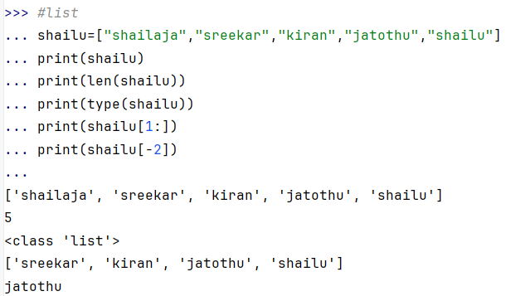

**append():**The append() method adds an element to the end of the list.

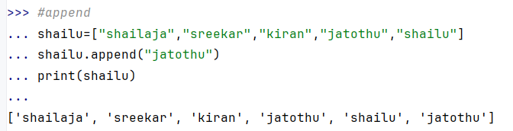

**insert():** The insert() method adds an element at a specified position in the list.

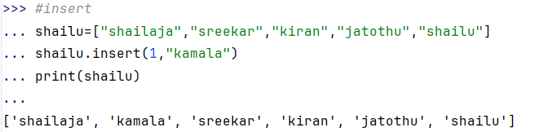

**extend():**The extend() method adds all elements of an iterable (like a list or tuple) to the end of the list.

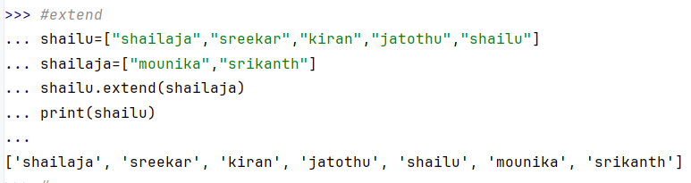

**remove():**Removes the first occurrence of the specified element from the list.

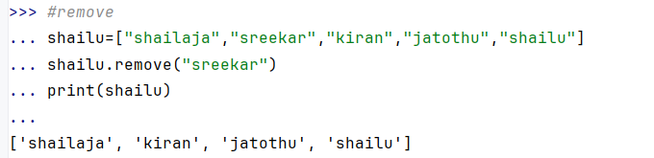

**pop():**Removes and returns an element at the specified index. If no index is provided, it removes the last element.

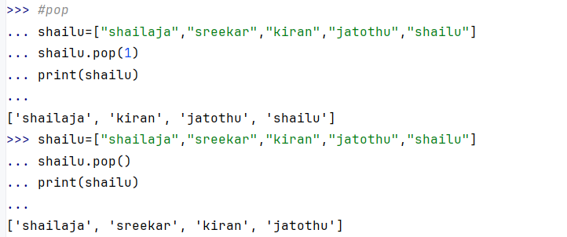

**sort():**Sorts the list in ascending order.

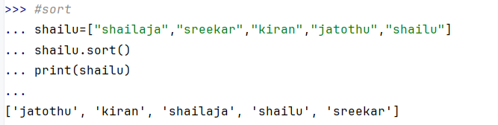

**count():**Returns the number of occurrences of a specified element in the list.

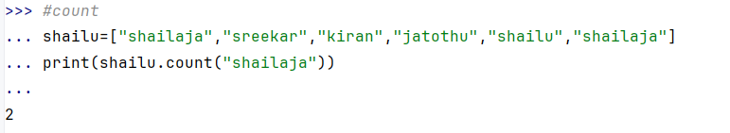

**clear():**Removes all elements from the list, making it an empty list.

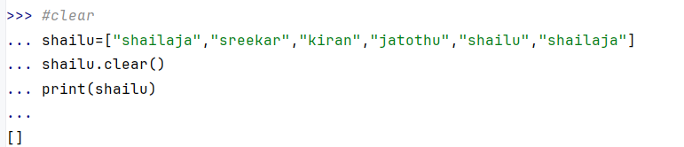

**copy():**Returns a shallow copy of the list (a new list with the same elements).

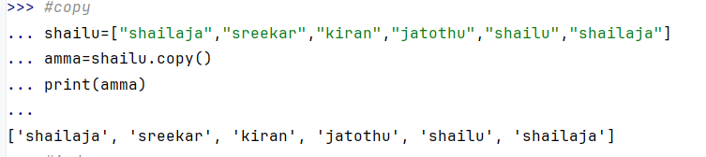

**index():**Returns the index of the first occurrence of a specified element.

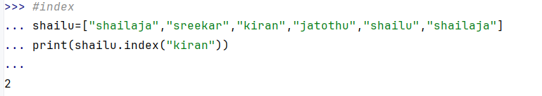

**reverse():**Reverses the order of elements in the list.

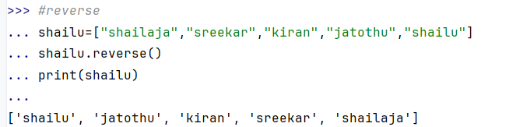

**Tuple**

**Creating a list**

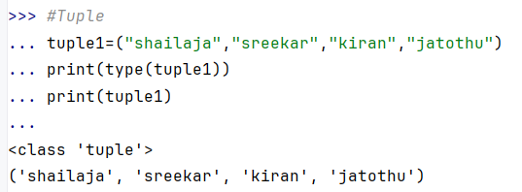

**Concatenation (**+=**):**You can concatenate tuples using +=, which combines them into a new tuple.

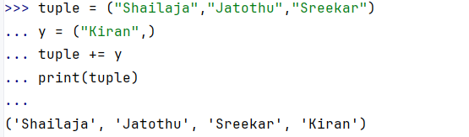

**count():**Returns the number of occurrences of a specified element in the tuple.

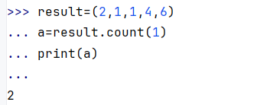

**index()**:Returns the index of the first occurrence of a specified element in the tuple.

